READING – TEST

1.

The African rainforests cover a very large area – from the west coast of Africa to the mountains in the East in Kenya and Tanzania. If you look at our map, you’ll see that more than 80 per cent of the rainforest is in the Congo basin. This time we’re going to mention a few larger mammals living in this area and a small animal from Madagascar. Madagascar, the world’s fourth largest island, lies off the southeast coast of Africa in the Indian Ocean. Some animals which live there can only be found in this part of the world.
2.

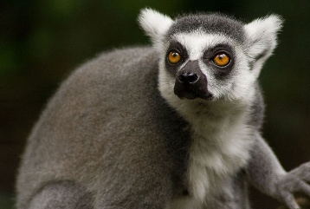
One such animal is the lemur. There are 25 species of lemur
on Madagascar and all of them are endangered. The lemur is a monkey-like animal with large round eyes, a pointed nose, a long tail and soft woolly fur. The largest lemur, the indri, is about 95 cm long, the smallest, the mouse lemur, is only 15 cm long. All lemurs are vegetarians. They like wild figs, bananas and other forest fruits.
3.

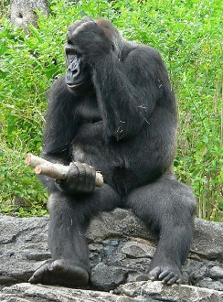
The mountain gorilla lives on the slopes of volcanoes in Rwanda, Zaire
and Uganda. They live in small groups led by a dominant male. They are too big and heavy to climb trees and so they wander slowly through the forest eating fruits, leaves and berries. They are the largest of the great apes and look very dangerous. But scientists say they are gentle, intelligent and very friendly.

4.
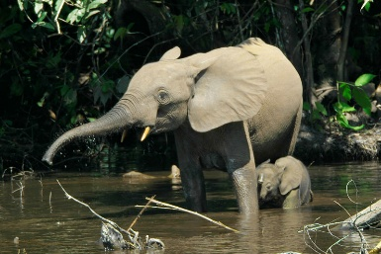
The forest elephant lives in the Congo basin. It is much smaller than the African elephant, which is the biggest animal on Earth.
Nevertheless, even this “small” elephant can be up to 250 cm tall.
Its ivory is thinner, short and a bit yellowish.
5.

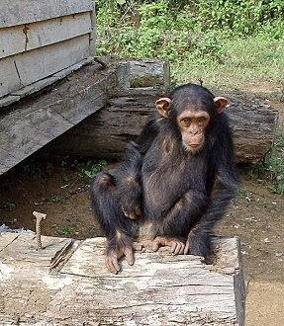
The African forest is also home to different kinds of chimpanzees
and baboons. Most chimpanzees use twigs to get tasty food from difficult places. Some can open nuts with stones and branches. Groups of about twenty chimpanzees travel together looking for fruit and leaves to eat.
At night they rest in tall trees in branches.

- Read this article. Write a suitable title which will describe what the text is about.
___________________________________________________________________________

- Look at the following titles of the paragraphs. Choose from the titles A – F the one which fits best each gap 1 – 5 in the article. There is one extra title which you do not need to use.
A – The biggest of the great apes
B – Searching for food together
C – Madagascar is my home
D – The fastest animal in Africa
E – A bit of geography
F – Taller than a man

- Find the information about animals and fill in the table.
 | Where do they live? (states – min. 1 item) | What do they eat?  (min. 2 items) | What do they look like? (min. 1 item)
Lemurs | Madagascar
Gorillas
Elephants |  | X | thin and short ivory
Chimpanzees | X |  | X

- Read the following sentences and decide if they are true (T) or false (F)? If they are false, correct them. If they are true, leave the line empty.

Example:
  - The African rainforests cover the area from the west coast to the lowlands in Kenya and Tanzania.
F – They cover the area from the west coast to the mountains in Kenya and Tanzania.

  - All lemurs are quite big – they are about 95 cm long.
________________________________________________________________________
  - The mountain gorilla lives in a small group with a dominant leader.
________________________________________________________________________
  - The African elephant is the biggest animal on Earth.
________________________________________________________________________
  - Chimpanzees sleep on the ground.
________________________________________________________________________
5) The lemurs on Madagascar are not protected.
________________________________________________________________________

- Read the short version of the article about animals and fill in the missing words according to it (only one word for each gap). The first has been done for you
as an example.
The rainforest (0) covers a very large part of Africa and Madagascar. It is home for many animals, some of which cannot be found anywhere else in the ________ (1). The lemur looks like a ____________ (2). It has got a long _________(3) and large round eyes. He loves eating various kinds of _________ (4),
for example bananas or figs. The mountain gorillas live in _________ (5) consisting of a chief and several other members. Because their weight is too __________ (6), they cannot climb the trees and they have
to look for food near the ground. The forest elephant is __________ (7) than the African elephant.
The colour of its ivory is somewhere between white and ___________ (8). Chimpanzees are very skilful – they can open nuts with branches or _____________ (9). They rest in the trees and eat the green __________ (10).

- Nine words are underlined in the article on the page 1. Match these words to their definitions. One has been done for you as an example. There are three extra words you do not need to use.
  - a large wet area covered with trees is called a ... rainforest
  - when an animal is strong and can kill you easily, it is … _____________
  - a soft coat which covers the animals’ bodies is … _____________
  - a part of the elephant’s head _____________
  - a very high hill _____________
  - a small, thin part of a tree _____________

ANSWER KEY
- Animals in the African rainforest / Animals in Africa / Animals in Madagascar and Africa etc.
the key words are “animals” and “Africa” (or “African rainforest”; they can also add “Madagascar”) –
I accept all variations containing these words
- 1 – E, 2 – C, 3 – A, 4 – F, 5 – B (D is not needed)
 | Where do they live? (states) | What do they eat? | What do they look like?
Lemurs | Madagascar | figs, bananas, (forest) fruits | large round eyes; a pointed nose; long tail; soft, wooly fur
Gorillas | Rwanda, Zair, Uganda | fruits, leaves, berries | big and heavy / largest of the great apes
Elephants | Congo / Congo basin | X | thin and short ivory
Chimpanzees | X | nuts, fruit, leaves | X

- 1) F – Not all lemurs are big / Some lemurs are big / Only some of the lemurs are big / The largest is about 95 cm long, the smallest is only 15 cm long. I will not accept the answer “Lemurs are small, they are only 15 cm long” because it means the summary of all the lemurs (it is the same mistake as in the sentence given “All lemurs are quite big…”)
2) T
3) T
4) F – Chimpanzees sleep in tall trees / in the branches / They rest in tall trees.
5) F – All lemurs on Madagascar are endangered. / The lemurs on Madagascar are protected.

- 1 – world, 2 – monkey, 3 – tail, 4 – fruit, 5 – groups, 6 – high / big, 7 – smaller, 8 – yellow (not yellowish), 9 – stones, 10 – leaves

- 1 – dangerous, 2 – fur, 3 – ivory, 4 – mountain, 5 – twig

EVALUATION
- 2 points (1 for the word “animals” and 1 for “Africa” or “rainforest”); I will take off
0,5 point for mistakes in grammar
- 5 points – 1 point for each correct title
- 7 points – they have to have at least one item in the first and in the third column, 2 items are required in the second one 1 point for each box; if they write only 1 item
in the second column = 0,5 point
- 8 points – 1 for the decision T / F and 1 for the corrected sentence; I would take off
0,5 point for an error in the sentence.
- 10 points – 1 point for each correct answer
- 5 points – 1 point for each correct answer

Maximum: 37 points
37 – 32 points ………. mark 1
31 – 26 points ………. mark 2
25 – 20 points ………. mark 3
19 – 14 points ………. mark 4
13 – 0 points ………... mark 5

Sources:
- HERINKOVÁ, Vlasta. Exploring rainforests: African rainforests. R&R : Časopis
na pomoc výuce angličtiny. January 2001, Year 11, no. 5, s. 11. (text)
- Dostupný pod licencí GNU Free Documentation License na www: <http://commons.wikimedia.org/wiki/File:South_Djoum_Chimp.jpg> (the photograph
of the chimpanzee).
- Dostupný pod licencí GNU Free Documentation License na www: <http://commons.wikimedia.org/wiki/File:Ringtailedlemur_-_24937.jpg> (the photograph
of the lemur).
- This file is licensed under the Creative Commons Attribution 2.5 Generic license: <http://commons.wikimedia.org/wiki/File:Loxodontacyclotis.jpg>(the photograph
of the elephant).
- Dostupný pod licencí GNU Free Documentation License na www: <http://commons.wikimedia.org/wiki/File:Gorilla_gorilla_gorilla4.jpg> (the photograph
of the gorilla).

